**Sant Shiromani Guru Ravidas Government College Sargaon, Dist-Mungeli (C.G.)**

**(College Code-2904) www.ssgrgcsargaon.ac.in email- ssgrgovtcollegesargaon@gmail.com**

**REPORT OF THE EXTENSION ACTIVITY**

**Date : 14.12.2021**

**Venue : Ward No.02, Nagar Panchayat Bhavan, Sargaon, Dist-Mungeli, (C.G)**

**Topic of Discussion : Possible Hazards of Household Chemicals**

**Organised by N.S.S., Y.R.C. and the Deptt. of Chemistry in collaboration with Sarpanch, Sargaon (C.G.)**

An activity under extension program was organized by NSS, YRC and the department of Botany on the date 14.12.2021 in Salfa village which in located near our college. Prior information was given to the Sarpanch after which he gave the approval for this extension activity. They provided the space for discussion on the topic “**Possible Hazards of Household Chemicals**” in Panchayat Bhavan of the Village. Dr. N. K. Singh and 23 students were also associating with Dr. Sandhya Patre, the resource person of this program. About 25 villagers including male and female participated in this program. After explaining the objectives of extension activities,possible hazards of household chemicals like sodium chloride, sodium bi carbonate, detergents, soap, naphthalene balls, chlorine tablets, boric powder, various insecticides and pesticides, paints, colors, dyes, recycled plastics, vinegar, phenyls, cosmetics, sindoor (lead tetraoxide), floor and toilet cleaners, deodorants, sprays, carbon tetra chloride based cleaners etc. were explained to the villagers. They heard the lecture patiently. .

During the course of the lecture, Dr. Patre cited some examples of critical accidents caused due to household chemicals. Certain chemicals are usually used in houses for various purposes. However, these may be fatal if consumed unknowingly by children. Their hazards and ways of protection for children were explained to the participating people. Especially women showed high degree of interest with regard to the effect of household materials. Someone asked about the possible bad effects of hair dyes. Some others were curious about the effects of face wash and cosmetics. All their curiosities were well explained by Dr. Patre.

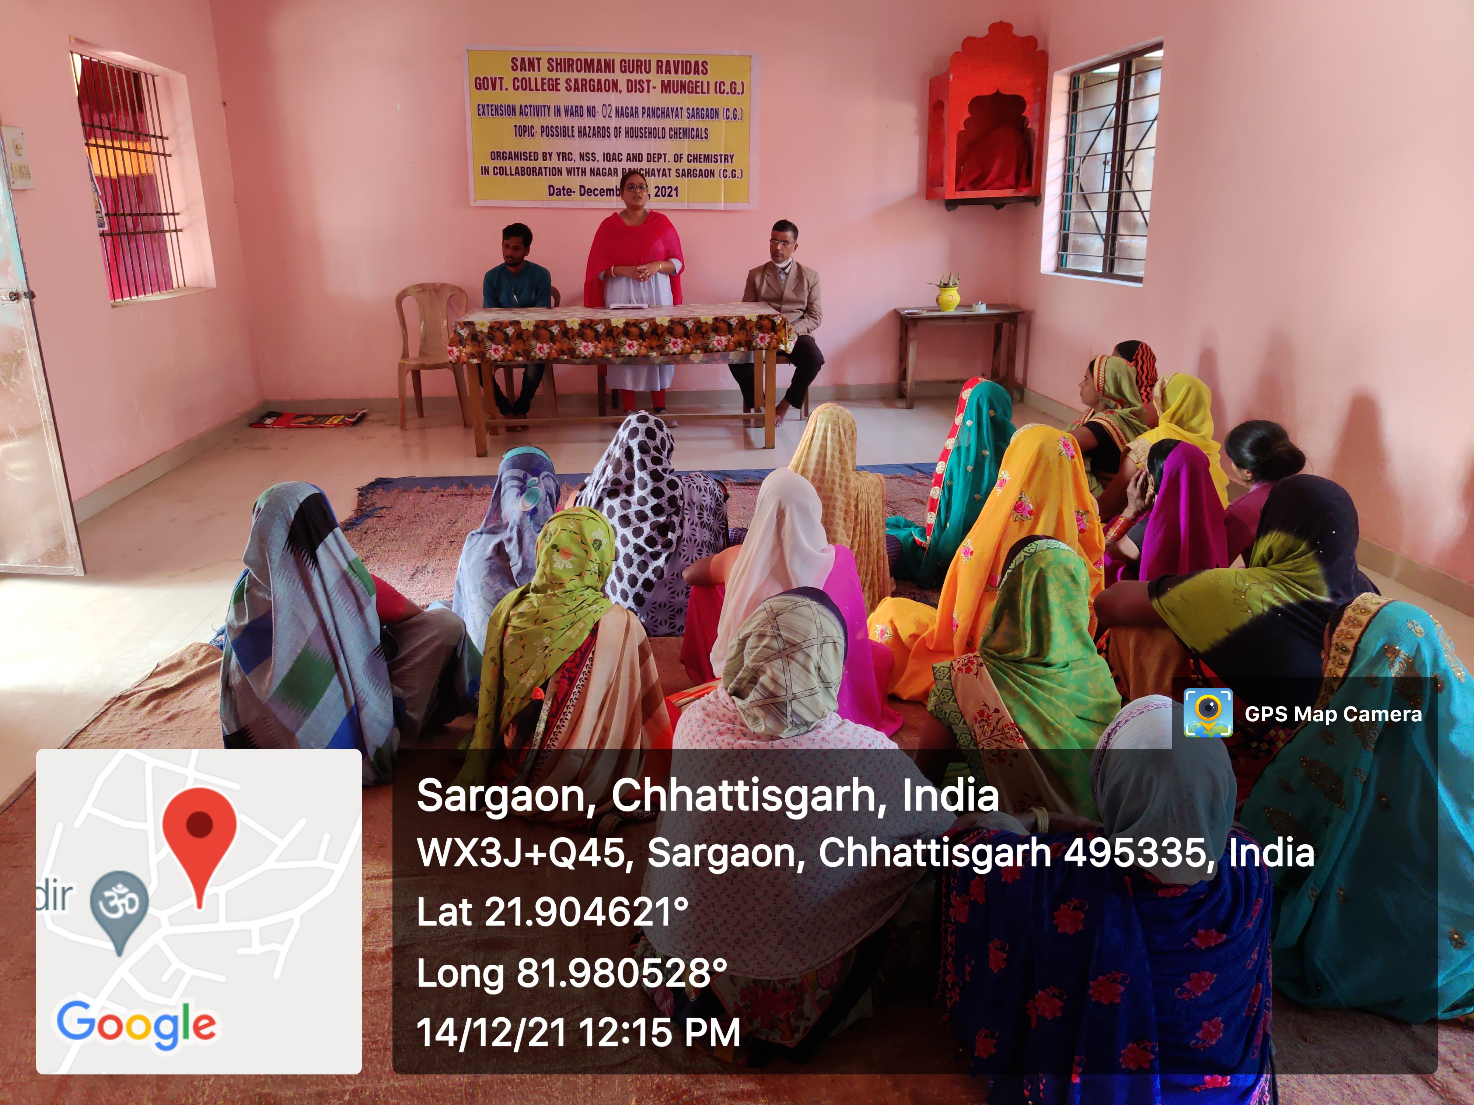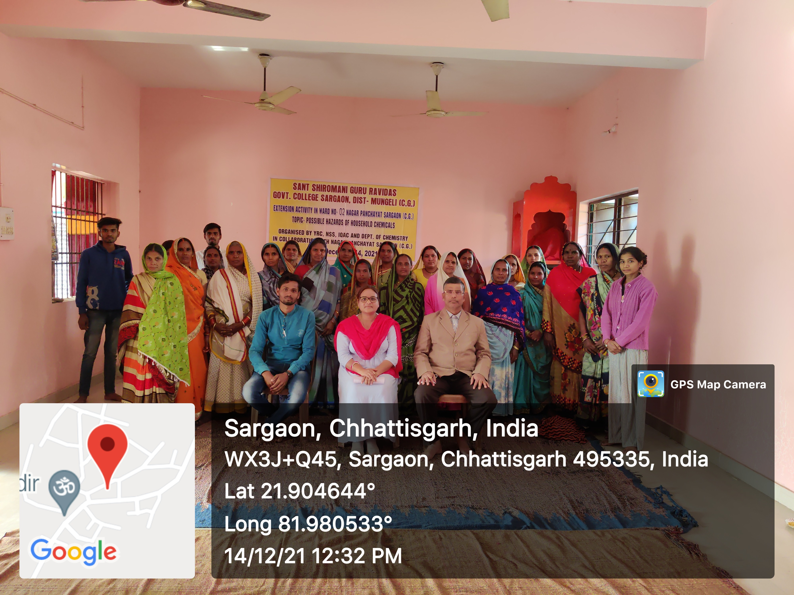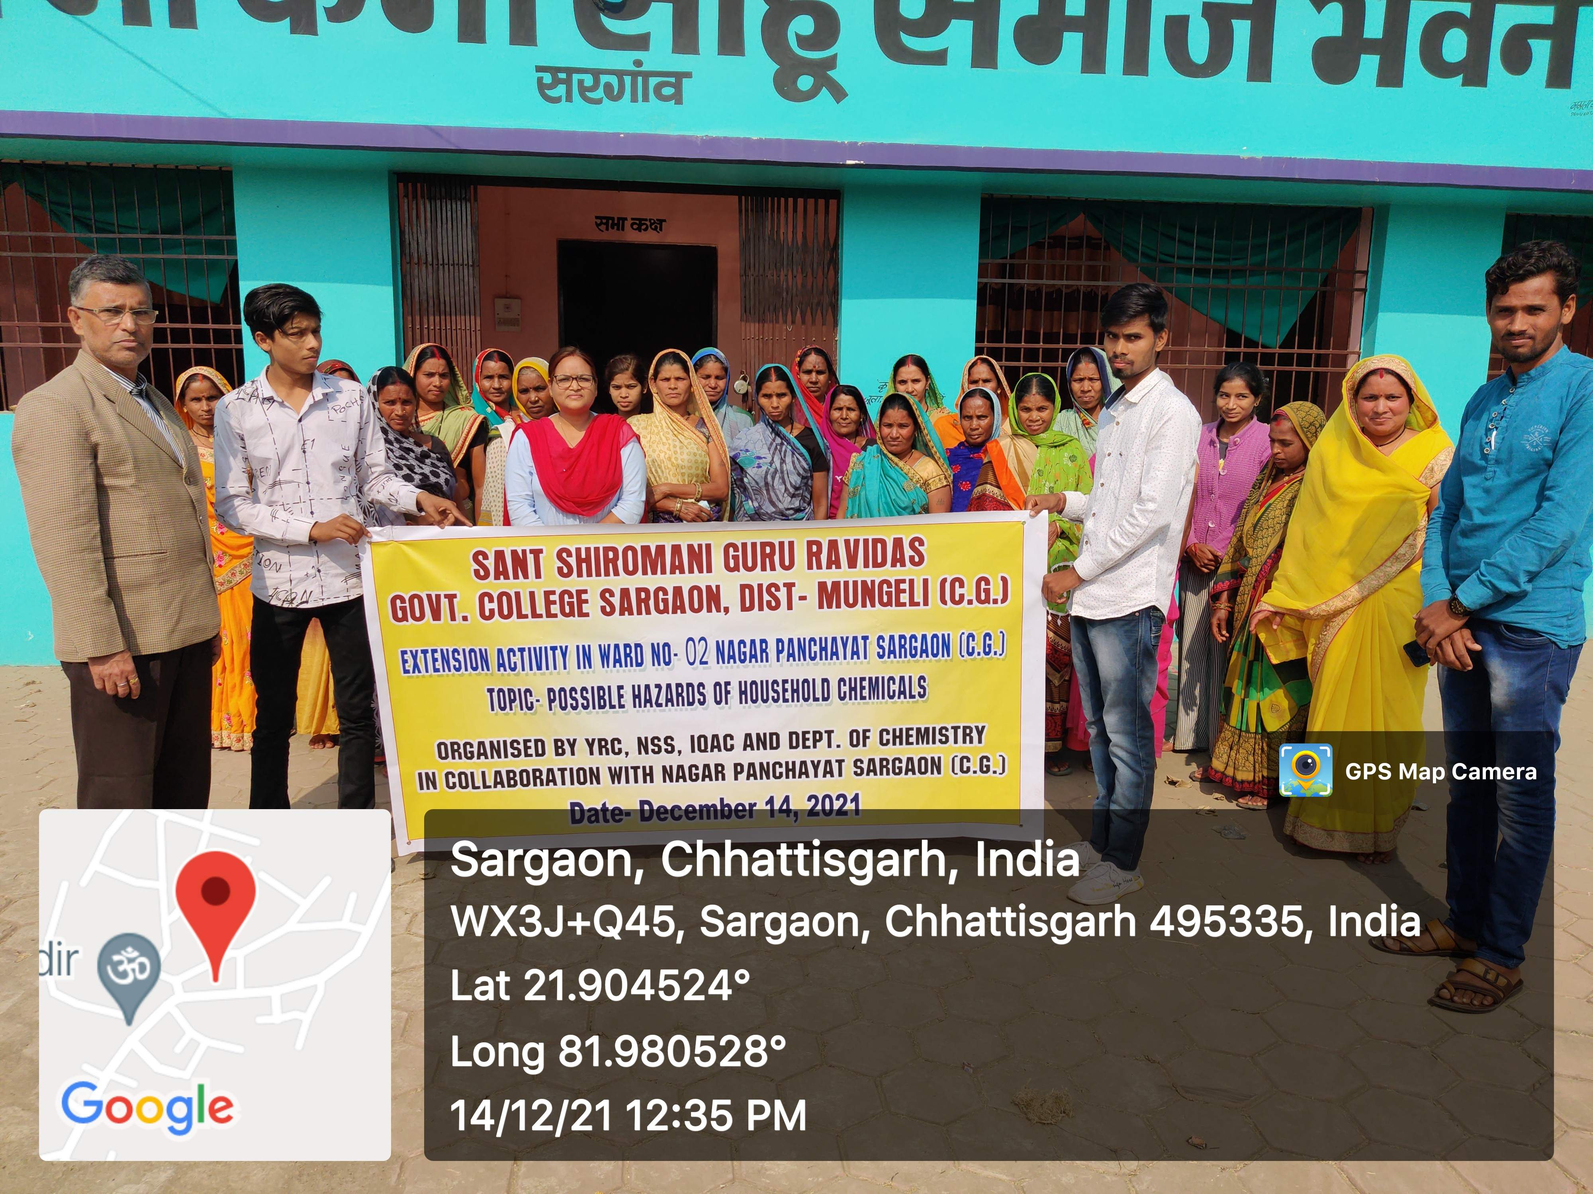

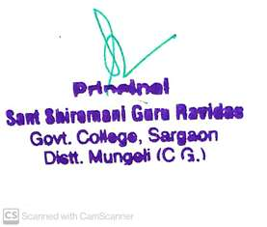

**List of students who participated in the Extension Activity organized in the Ward No.02, Nagar Panchayat Bhavan, Sargaon, Dist-Mungeli, (C.G), on the date of 14.12.2021**

1. Nitesh Kumar, B.Sc. I
2. Rahul Verma, B. Sc. II
3. Durgesh, B. Sc. II
4. Durgeshwari Nishad, B. Sc. II
5. Ajay Sahu, B. Sc. II
6. Lala Sahu, B. Sc. II
7. Karan Kumar Kaushal, B. Sc. II
8. Anjali, B. Com I
9. Rupa Sahu Sahu, B. Com. II
10. Rashmi Lahre, B. Sc. II
11. Sanju Verma, B.Sc. II
12. Nikhil Verma, B. Sc. I
13. Sumita, B.Sc.I
14. Neha, B.Sc.I
15. Pratibha, B.Sc.III
16. Manisha, B.Sc.III
17. Sangita Tandan, B.Sc.I
18. Bindu, B.Sc.II
19. Simran, B.Sc.II
20. Arun, B.Sc.II
21. Vikash, B.Sc.I



1. Himesh, B.Sc.II
2. Versha Sahu, B.Sc.II